Risk & Risk Management Process

Risk Definitions Over Time
Risk is not an easy concept to define – and can have different meanings depending on context and situation. One of the challenges of risk management is ensuring that all parties have a common understanding of risk.
Blakely et al define risk as "the possibility of an event which would reduce the value of the business were it to occur. Such an event is called an 'adverse event' ".

They also define a measure of risk as 'annualised loss expectation' (ALE).

"ALE is the expected cumulative cost of risk over a period of one year as estimated in advance."
Blakely et al, 2002
Simply means: How much money you expect to lose from a risk in one year.
Stoneburner et al define risk as "the net negative impact of the exercise of a vulnerability, considering both the probability and the impact of occurrence".
"Risk management is the process of identifying risk, assessing risk, and taking steps to reduce risk to an acceptable level". Stoneburner, 2002
Break it down:
- “Vulnerability” → a weakness (e.g., no encryption, weak password)
- “Exercise of a vulnerability” → when an attacker actually exploits that weakness
- “Probability” → how likely it is to happen
- “Impact” → how serious the damage would be
Quick example:
- Website has no HTTPS → vulnerability
- Hackers can intercept data → exploitation
- If it happens often (high probability) and exposes user data (high impact)
👉 Risk = High
Hubbard (Hubbard, 2009) spends an entire chapter of his book discussing the various definitions of risk that are used – his preferred definitions are given below:
Definition of Uncertainty
–
"Uncertainty .. Is the existence of more than one possibility. The “true” outcome/ state/result/value is not known."
Definition of Measurement of Uncertainty
–
"Measurement of uncertainty (is by) a set of probabilities assigned to a set of possibilities. For example: there is a 60% chance it will rain tomorrow, and a 40% chance it won’t.”
Definition of Risk
–
"A state of uncertainty where some of the possibilities involve a loss, injury, catastrophe, or other undesirable outcome (i.e., something bad could happen)."
As mentioned above in chapter 5 of his book Hubbard reviews various risk definitions – a link to an online version is given in the references.
"The Open FAIR Body of Knowledge defines risk as the probable frequency and magnitude of future loss."
Josey et al, 2014
In formal terms risk is derived from the combination of threat event frequency, vulnerability, and asset value and liability characteristics".
"Information risk is a subset of business risk and relates to the confidentiality, integrity and availability of business information assets and the information management ... the general principles of business risk management still apply"
Sutton, 2016
He also supplies the risk process diagram as shown in figure 1 below – the chapters referring to the sections in the course text dealing with each step. We will discuss these steps later on within this session.
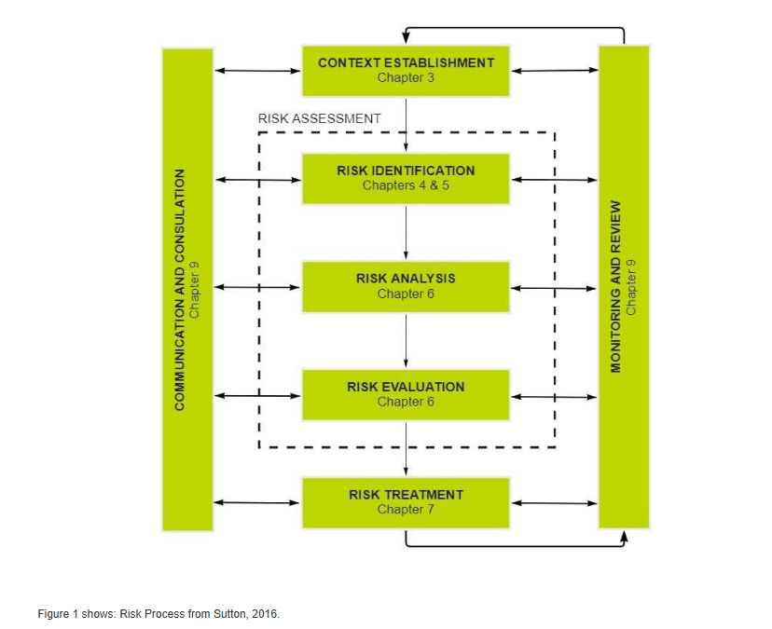
The main concepts that underpin Information Security Management – the so called 'three tenets of security' (Campbell, 2016) are:
- Confidentiality.
- Integrity.
- Availability.
Increasingly many sources also add Non-repudiation to that list.
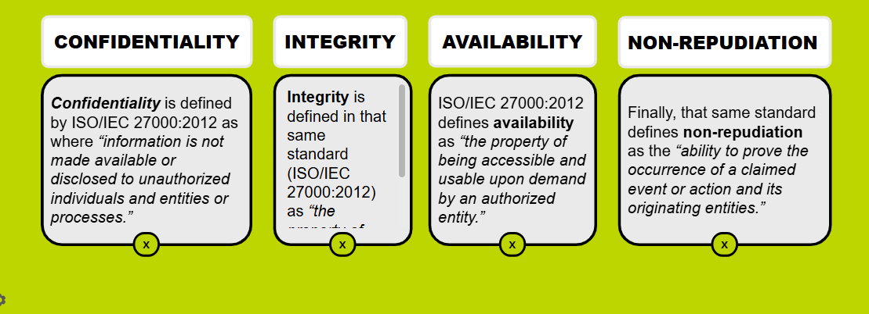
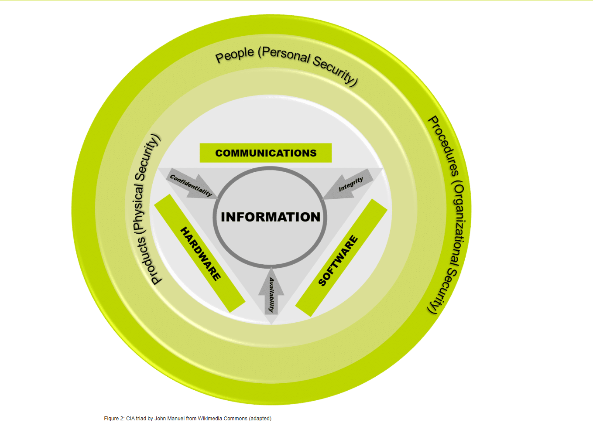
Threats and Vulnerabilities ISO/IEC 27000:2012 defines a threat as “the potential cause of an unwanted incident, which may result in harm to a system or organization.” And defines a vulnerability as “a weakness of an asset or control that can be exploited by one or more threats.”. The importance of any threat or vulnerability is very much dependent on the probability of it occurring – hence both are closely related to risk assessment processes – and a specific example of such a process is commonly referred to as threat modelling. Threats can be physical (I.e. pertaining to buildings or people) or technical (I.e. pertaining to technical assets – either hardware or software). Vulnerabilities also exist in the same domains.

Systems for Strategy, Intellectual Resource, Technology, Structure and Management
Risk Management Process (RMP) Information risk is a key business element that affects and impacts all aspects of a company. A (new) risk management system in a company may well require implementation as a programme, rather than a project, due to its scope. For any such programme to be successful it must have proper governance, buy-in and contribution from senior management and involve the heads of all major departments within the company. It must ensure that all appropriate standards and certifications are known, and that the company is compliant from both a legal and regulatory perspective.
Hoffmann et al (Hoffman et al, 2016) recommend treating the organisation as a system consisting of 5 major parts. Click on each card to learn more about them:
- The strategy system: Supplies tasks and Objectives - What the company wants to achieve. i.e. “Provide secure and fast online banking services”
- The Intellectual Resource: Consisting of people’s efforts and behaviours. Knowledge and expertise. i.e. Cyber security skills, developers’coding knowledge, customer data insight
- The Technology System: Consisting of materials and technical equipment. Tools and systems used. i.e. Firewall, HTTPS, Banking software
- The structure System: Supplying formal structures and procedures. How the company is organised i.e. IT Department, Cybersecurity Team, Customer Support
- The Management System: Supplies, monitors and drives the attainment of goals. How things are controlled and managed. i.e. Security policies (i.e. password rules)
Using a model such as this helps to clarify the interaction required between departments and the risk management process.

The Information Security Management System (ISMS)
Both the Hoffman paper and the course text recommend that any risk management process be tightly coupled to other existing management systems – such as quality and the information security management system (ISMS).
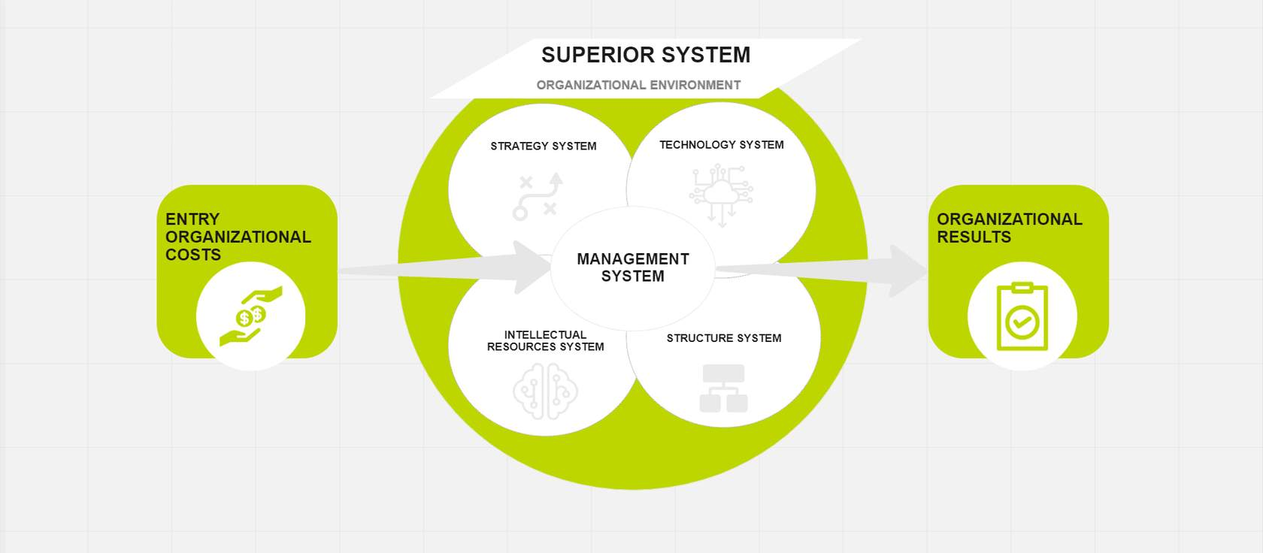

The PDCA Mandate : Plan-Do-Check-Act
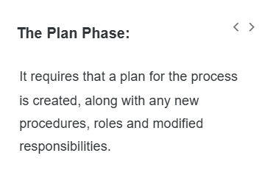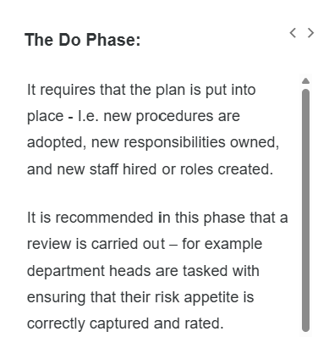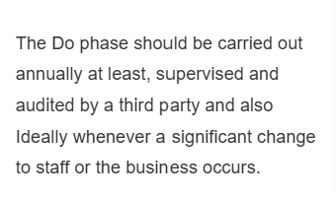
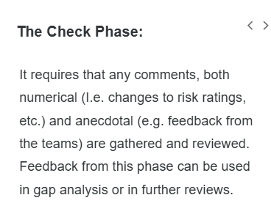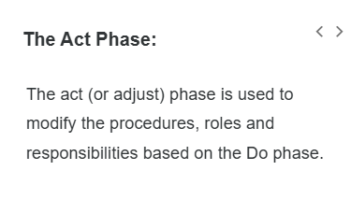
Risk identification – Control and Procedures
There is a need to evaluate risk as a core aspect of the ISM role, but with an awareness of the semantic issues we need to collect and analyse risk from as many different perspectives as possible.
Different people understand “risk” differently:
- A technical engineer → risk = system vulnerability
- A manager → risk = financial loss
- A legal team → risk = compliance/legal problems
👉 So the same word (“risk”) has different meanings depending on perspective

Gathering Data
Campbell (Campbell, 2016) recommends the production of a risk register that collects and collates risks from as wide a variety of sources as possible, so he recommends gathering data from:
- Risk notification mailboxes
- Threat workshops
- Business impact assessment
- Gap analysis
- Security Audits
ANALYSING THE RISKS:
Once the above approaches have been used to gather as many risks as possible the next challenge is to analyse the risks – which means assigning them either a numerical (quantitative) or subjective (qualitative) assessment value.
QUALITATIVE ASSESSMENT:
Qualitative assessment may consist of asking pertinent staff to evaluate a risk as minor, medium or major. These can be assigned a numerical value later, if desired.
QUANTITATIVE ASSESSMENT:
Quantitative assessments would use statistical or historical data to evaluate and assign a weighting to a risk.
Some (Hubbard, 2009) would argue that qualitative assessments are less useful and that numerical methods should be preferred,.
But as Busch points out (Busch, n.d.) not all risks can be evaluated numerically, risk is subjective, and precluding qualitative assessment may exclude useful input from less numerically oriented staff.
CLASSIFY THE RISKS:
Once the analysis has taken place the final part of risk management is the mitigation phase – this is where each risk is classified as being in one of four categories:
- bullet
Eliminate (I.e. should it be removed or avoided completely);
- bullet
Tolerate (where a risk is recorded but no other action is taken, usually due to a cost-benefit analysis);
- bullet
Reduce (where the impact of a risk is minimized by preventative action) or;
- bullet
Transfer (where the cost of mitigation and or impact of a risk is shared between multiple stakeholders).

Mitigating Mechanisms
Lesson 6 of 13
Once a risk has been classified there are a number of mitigation mechanisms available, primarily these consist of:

The controls:
Once a risk has been classified there are a number of mitigation mechanisms available. Click on the arrows to navigate what these primarily consist of.

PHYSICAL CONTROLS
Such as security guards/patrols, alarms systems and CCTV.

PROCEDURAL CONTROLS
Such as new processes or procedures that affect staff as part of their induction, annual training or even changes to their employment contracts.
TECHNICAL CONTROLS
Involving adding or modifying the technical components used as part of the security stack such as new or improved firewalls, IDS systems or SIEM A document has been found to be susceptible to tampering:
Risk to the company:
Any changes could reduce the responsibility of a third party to assess and mitigate technical debt in a development product, which would lead to additional costs and the possibility of reputational damage.
Final evaluation: high impact risk but with a low to medium chance of it occurring.
(security information and event management) solutions.
Which possible mitigating mechanisms could be applied in this scenario?
Some options include:
- Using a software product to manage editing, storing it read-only on a (new) secure server or;
- Using a version control system to audit access and keep old versions to easily revert to.
Solution: as SharePoint was available that was selected as an appropriate and cost effective solution.

Risk = Threat x Vulnerability x Asset

As we discussed previously when we reviewed the definitions of risk, most sources would agree at a basic level with the following equation:

Risk = Threat * Vulnerability * Asset
Based on OPEN Fair definition. Equation is from Wikicommons.
The conflicts arise when we look at how to assign numerical values to threats and vulnerabilities.
We will assume that any asset that is being protected has a financial value that can be calculated.
Most organisations will use both qualitative and quantitative assessment methods.

Qualitative Assessment
–
It is used for lower value assets or when the people performing the assessment do not have the appropriate training or skills to perform a quantitative assessment, or where the necessary amount of data is not available.

Threats and/or vulnerabilities are assigned to categories such as high / medium / low - even if numerical values are assigned at a later date to ease with cost calculations or attribution.

Once categorisation has been made then the calculation discussed previously can still be performed so that a numerical, or even financial risk can be assigned to each potential threat. We will discuss the validity of this value later.

Quantitative Assessment
–
It is a well defined, mathematical calculation. It often involves the use of probabilities and game theory and is widely used by insurance companies when creating indemnities against certain risks occurring.

Hubbard (Hubbard, 2009) discusses quantitative assessment in great detail and categorises the types of people that he believes can perform these calculations into four areas – his so called '4 horsemen', which we will explore further in the next section.
Qualitative or quantitative assessment?

The 4 Horsemen - Quantitative Assessments
Hubbard (Hubbard, 2009) categorises the types of people that he believes can perform these quantitative calculations into four areas.

These are the kinds of professionals who can estimate risk using data, maths, and probability.
1.Actuaries: Experts in risk and probability (usually insurance)
✅ Example:
“What's the chance of a data breach and how much will it cost?”
2. War Quants
👉 Military analysts who use maths and models for decision-making

✅ Example:
“What's the probability of a cyberattack and best defence strategy?”
3. Economists
👉 Focus on financial impact and cost analysis
“Is it cheaper to fix this vulnerability or accept the risk?”
4. Management Consultants
👉 Business advisors who use data to guide decisions
✅ Example:
“What risks should the company prioritise to protect profits?”
What’s the main idea?
👉 All four groups:
- Use numbers, data, and models
- Help estimate risk in measurable terms (money, probability, impact)
Quantitative vs Qualitative - The Pros and Cons
👉 Pure quantitative risk analysis (using numbers and data) is difficult because many organisations don’t have enough data.
👉 Quantitative risk analysis sounds good, but in reality many companies can’t use it because they don’t have enough data, and important data (like insurance data) is kept private.
👉 A key limitation of quantitative risk analysis is the lack of accessible and reliable data, particularly for smaller organisations, as valuable actuarial data is often proprietary and not publicly shared.
There is a debate:
- Hubbard → prefers numbers (quantitative)
- Busch → says you still need human judgement (qualitative)
Hubbard believes:
- Using numbers, data, and calculations is better
- Subjective opinions are less reliable
Busch disagrees and says:
- Not everything can be measured with numbers
- Risk is subjective (depends on people’s views)
- If you ignore qualitative input:
  - You lose valuable insights
  - Especially from non-technical staff
All of these standards bodies have developed detailed methods based on scoring (I.e. qualitative) approaches. None indicate even an awareness of better methods that could be applied other than to presume that any method slightly more scientific would have to be impractical
Hubbard, 2009
This assertion is not completely true as we will discuss when looking at some of the standards and bodies that determine the nature, and future of Information Risk Management (Hubbard pg 43 & 92).

Open FAIR
There are a number of standards specific to the risk process as well as some that mention or encompass risk in some way. The major ones will be discussed in this section. Open FAIR is a standard produced by the Open Group – who have a long and illustrious history as the certifying body for the UNIX trademark – although nowadays it is far better known for its work in enterprise architecture – certifying both the TOGAF architecture examination and the ArchiMate software tool.
FAIR is an acronym for "Factor Analysis of Information Risk" (Josey et al, 2014). It consists of two documents, the open risk taxonomy (O-RT) which defines the taxonomy for the factors driving information risk; and the open risk analysis (O-RA) which describes the process and procedures associated with performing risk analysis
👉 FAIR = Factor Analysis of Information Risk
👉 It is a framework used to understand and measure cybersecurity risk using numbers

What are the two parts of FAIR?

1. O-RT (Open Risk Taxonomy)
👉 Defines what risk is made of
It breaks risk into clear components like:
- Threat (who/what causes harm)
- Vulnerability (weakness)
- Loss (impact in money)
- Frequency (how often it happens)
👉 Think of it as:
🧩 “What pieces make up risk?”

2. O-RA (Open Risk Analysis)
👉 Explains how to analyse risk step by step
- How to calculate probability
- How to estimate financial loss
- How to combine everything into a final risk value
👉 Think of it as:
📊 “How do we calculate and measure risk?”
According to the Open Group (Josey et al, 2014) the reasons to use Open FAIR are:
As opposed to emphasis on controls or instrumentation (👉 Open FAIR is useful because it helps organisations analyse risk properly using data, not just guesswork.
👉 Instead of only focusing on:
- Security tools (firewalls, antivirus)
- Controls (policies, procedures)
👉 FAIR focuses on:
✅ Understanding the actual risk first
).
Providing guidance on how to do analysis.( 👉 FAIR gives:
- A clear method
- Step-by-step way to analyse risk
Simple:
)
Focus on data and probabilities whenever possible (FAIR encourages:
- Using numbers and evidence
- Estimating likelihood and impact
).
Adaptable according to availability of resources and data.
FAIR is flexible:
- If you have lots of data → do detailed analysis
- If you have limited data → still usable with estimates
Designed to avoid gaps and errors caused by heuristics (Investigative approach to problem solving) and bias.
- Reduce guesswork
- Avoid personal bias
- Make risk analysis more objective
Simple:
👉 It helps you avoid wrong decisions caused by assumptions.
Open FAIR is designed to work with, and be compatible with a number of other alternative standards including:
- bullet
ISO 31000
- bullet
ISO 27001
- bullet
ISO 27005
- bullet
COSO ERM
- bullet
SABSA (Sherwood Applied Business Security Architecture)
- bullet
COBIT (Control Objectives for Information Technology)
- bullet
OCTAVE
- bullet
NIST 800-30
Many of these will be discussed later. As an example the Open Group Security forum have created a mapping guide called the FAIR – ISO 27005 cookbook.
The following diagram of the Open FAIR taxonomy illustrates the factors that contribute to risk according to Josey's model (2014). Click on each marker to learn more about the definition of each element:

Fair Risk Model
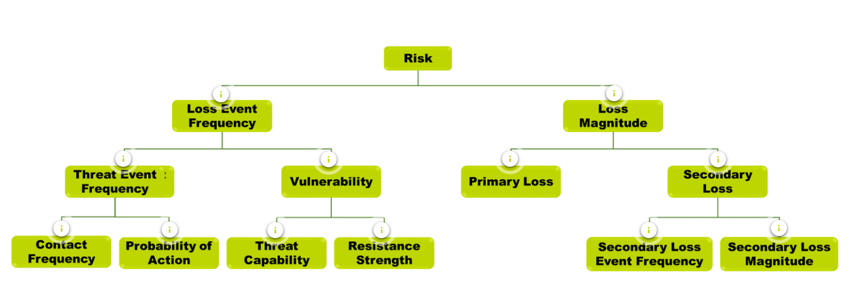

LEF (Loss Event fr.) = It is a probable frequency, within a given timeframe, that a threat agent will inflict (Tahmil Kardan) harm upon an asset .
LEF = How often it happens
LM = How big the damage is

Threat Event Frequency (TEF)

🔹 LEFT SIDE: Frequency (How often?)

1. Threat Event Frequency (TEF)
👉 How often attackers try
- Contact Frequency → How often they reach you
- Probability of Action → How likely they attack

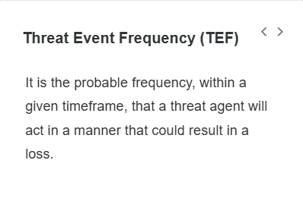
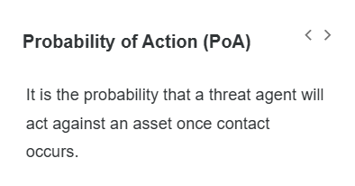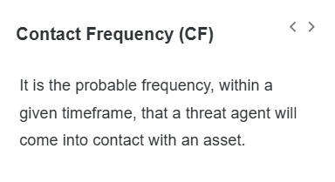

Vulnerability
👉 How likely the attack succeeds
- Threat Capability → attacker skill
- Resistance Strength → your defence

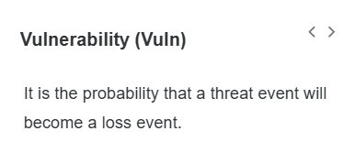

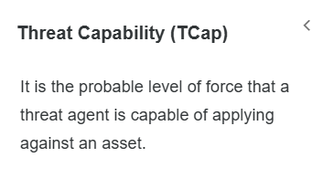
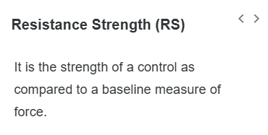

👉 So:
🧩 LEF = TEF + Vulnerability

🔹 RIGHT SIDE: Impact (How much damage?)

1. Primary Loss
👉 Direct damage
- Money lost
- Data stolen

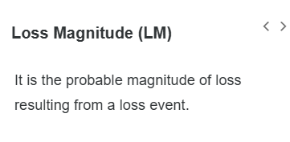
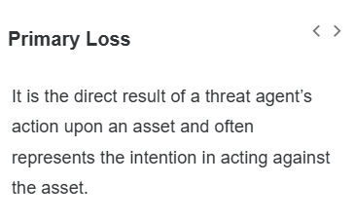

2. Secondary Loss
👉 Indirect damage
- Reputation loss
- Legal fines
- Secondary Loss Event Frequency → how often follow-up damage happens
- Secondary Loss Magnitude → how big it is

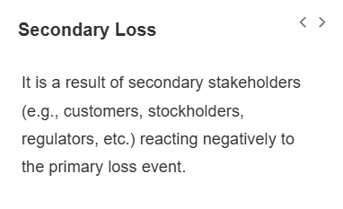
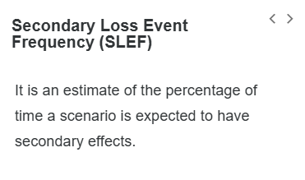
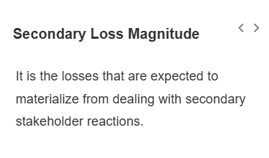

🎯 EASY MEMORY TRICK
👉 Think:
“How Often × How Bad”
- LEFT = How often
- RIGHT = How bad

Example from Open Fair

Columns meaning:
- Minimum → best case
- Average → expected case
- Mode → most likely
- Maximum → worst case

🔹 Primary Loss
- Happens 0.17 times/year (~once every 6 years)
- Average loss ≈ $393K

🔹 Secondary Loss
- Happens less often (0.07/year)
- But can be very expensive (millions!)

🔹 Total Loss Exposure
👉 Final answer:
👉 Average risk ≈ $316,229 per year
👉 Total Loss = Frequency × Loss Amount

🔹 CORE IDEA (remember this)
👉 Total Loss = Frequency × Loss Amount

🔹 Step 1: Understand what we multiply
From the table:

✅ Primary Loss
- Frequency = 0.17 times per year
- Loss = $393,005
👉 Calculation:
$$0.17×393005$$
👉 ≈ $66,810

✅ Secondary Loss
- Frequency = 0.07 times per year
- Loss = $3,689,381
👉 Calculation:
$$0.07×3689381$$
👉 ≈ $258,256

🔹 Step 2: Add them together
👉 Total Loss:
$$66810+258256$$
👉 ≈ $316,000 per year
✔️ This matches the table: $316,229

🔥 SUPER SIMPLE WAY TO REMEMBER
👉 Think:
Risk = (How often × Cost) + (How often × Cost)
Or even simpler:
👉 Primary Loss + Secondary Loss = Total Risk

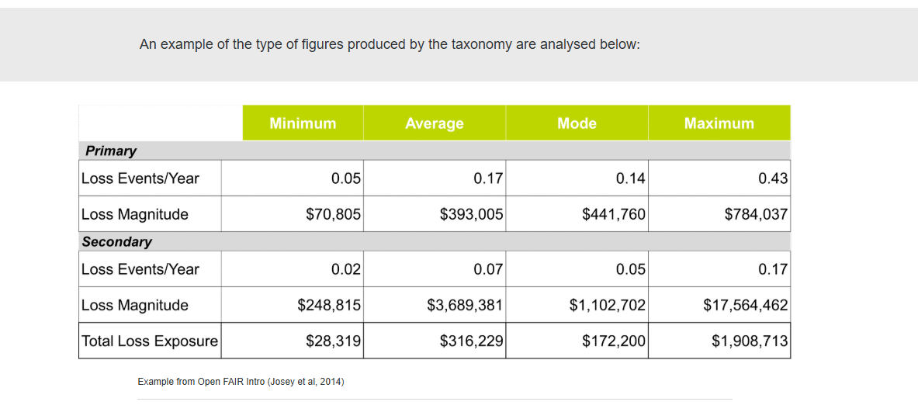

OCTAVE Framework
The Operationally Critical Threat, Asset and Vulnerability Evaluation (OCTAVE) framework standard was created at Carnegie Mellon University (CMU) in 1999 (Alberts et al, 1999).
OCTAVE was (is) a mix of 3 different programs:
- 1
1
Information Security Evaluation (ISE) - which was a vulnerability evaluation system focussing on computing infrastructure;
- 2
2
CMU's Software Engineering Institute (SEI) risk program software risk management expertise;
- 3
3
Information Security Risk Management (ISRM) survey and research.
According to (Alberts et al, 1999) OCTAVE consists of 3 phases:

PHASE 1
–
BUILD ENTERPRISE-WIDE SECURITY REQUIREMENTS

Phase 1 uses many of the techniques previously discussed in this section to produce a list of security requirements, assets and potential threats.

PHASE 2
–
IDENTIFY INFRASTRUCTURE VULNERABILITIES

Phase 2 maps the information assets to the information infrastructure, then an infrastructure vulnerability assessment is carried out, focusing especially on components highlighted by the mapping exercise.

PHASE 3
–
DETERMINE SECURITY RISK MANAGEMENT STRATEGY

Phase 3 builds on the previous phases.

According to Alberts (Alberts et al, 1999):
"Risks are identified by analyzing the assets, threats, and vulnerabilities identified in OCTAVE’s earlier phases in the context of standard intrusion scenarios.
The impact and probability of the risks (also called the risk attributes) are estimated and subsequently used to help prioritize the risks.

The prioritized list of risks is used in conjunction with information from the previous phases to develop a protection strategy for the enterprise and to establish a comprehensive plan for managing security risks".

